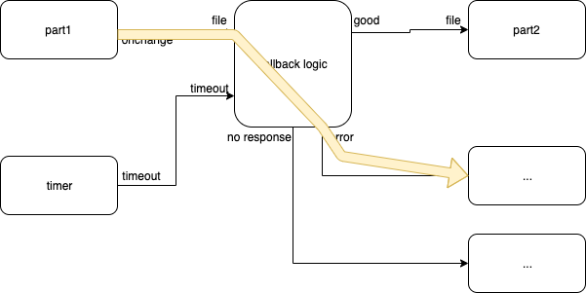
Fig. <$n:figure:ErrorPath> Error Path

The yellow arrow shows what happens when the system (e.g. HTML) finds something wrong.

